**Mansoura University**

**Faculty of Computer and Information Science**

**Medical Informatics Department**

**Artificial Intelligence Department**

**“An Intelligent Approach for Oral Cancer Diagnosis”**

**Supervised by**

* **Prof. Hazem ElBakry**

**2023 - 2024**

**Team Members**

**Bio**

**Ai**

**Preface: Unveiling the Shadows of Oral Cancer**

Welcome to an in-depth exploration of a pervasive and often misunderstood adversary: oral cancer, commonly known as mouth cancer. This intricate disease unfurls as a tumor within the oral cavity, impacting the delicate skin lining inside the mouth. Its insidious nature often cloaks its presence, manifesting as a rough patch or an unyielding lump—a silent menace that commands our attention.

Mouth cancers, in their diverse manifestations, appear as growths or sores in the oral cavity that persistently defy resolution. While smoking takes a central role, it is not the exclusive culprit of this formidable foe. The interplay of smoking and alcohol consumption heightens the risk, casting shadows of vulnerability over those engaging in both habits. Herein lies a stark reality: men bear a disproportionate burden, a pattern mirroring their higher prevalence of alcohol consumption. It forms an intricate web of factors contributing to the alarming statistics.

Embark with us into the domain of cutting-edge technology—an arena where the fusion of artificial intelligence and sophisticated deep learning algorithms promises revolutionary transformation. Our expedition intricately explores the seamless integration of these technological marvels into the fabric of healthcare, specifically within the realms of remote consultation and prompt diagnosis. Mobile phone imagery, omnipresent in our daily routines, acts as the dynamic canvas on which this paradigm shift materializes, ensuring not only accessibility and efficiency but, most crucially, facilitating timely and imperative intervention.

In our pursuit of advancing healthcare solutions, we have successfully developed an artificial intelligence and machine learning model specifically tailored for the detection of oral cancer. This innovative model harnesses the power of cutting-edge technologies to analyze intricate patterns and anomalies associated with oral cancer in medical imaging. Through the integration of state-of-the-art algorithms, our AI/ML model showcases remarkable capabilities in early detection, offering a transformative approach to identifying potential risks and facilitating timely intervention. This marks a significant stride in leveraging technology to enhance our ability to combat and manage oral cancer effectively.

**Acknowledgement**

Foremost, we extend our deepest gratitude to Allah for His continuous blessings, guidance, and support throughout the journey of our oral cancer detection project. Our heartfelt appreciation goes to our parents, whose unwavering support and encouragement have been the cornerstone of our dedication and hard work. We are committed to making them proud of their sons/daughters through our achievements.

Special acknowledgment is due to our esteemed supervisors, Prof. Hazem ElBakry, whose guidance and mentorship have been invaluable. Their unwavering commitment to excellence, encouragement, and provision of crucial information and advice propelled our project towards success. We are profoundly grateful for their continuous support, kind communication, and efforts to foster our interest in the profound work we undertook. Their influence has been instrumental in shaping the trajectory of our research, and for that, we express our deepest appreciation.

**Abstraction**

Oral cancer represents a significant and pressing health concern globally. According to the World Health Organization (WHO), there is a projected and sustained increase in the worldwide incidence of oral cancer, a trend anticipated to persist over the coming decades. In the United States alone, the WHO predicts an annual surpassing of 31,000 new cases of oral and oropharyngeal cancer. Alarmingly, mortality rates associated with cancers in this region outpace the annual death rates caused by cutaneous melanoma or cervical cancer.

Etiological factors contributing to oral cancer in Western countries encompass sunlight exposure, smoking, and alcohol consumption. Leveraging advanced technology and employing deep learning algorithms, early detection and classification have become feasible through medical imaging techniques and computer-aided diagnosis. This paradigm shift has the potential to bring about transformative changes in cancer treatment methodologies.

This project focuses on the development of an automated detection system that integrates artificial intelligence to analyze mobile phone images. This approach facilitates remote consultations, offering a promising avenue for enhanced accessibility and efficiency in healthcare systems. Utilizing deep learning for classification, our results demonstrate superior outcomes compared to conventional models. The analysis of our model's performance on collected images underscores the value of common imaging patterns on smartphones as a valuable approach for early diagnosis. This advancement marks a significant stride towards leveraging technology for more effective oral cancer detection and subsequent interventions.

**Chapter 1**

**Introduction**

**Introduction**

**1.1 Problem Definition**

The overarching problem we address is the late detection and limited awareness surrounding oral cancer. Despite advancements in healthcare, delayed identification remains a critical issue, impacting treatment outcomes and patient prognosis. Our AI model aims to revolutionize early detection, offering a proactive solution to combat the challenges posed by oral cancer.

**1.2 Oral Cancer Causes**

Oral cancer primarily stems from various risk factors, including

* Tobacco
* alcohol use
* epstein-barr virus (EBV)
* HPV (human papillomavirus)
* family history of mouth cancers
* poor oral hygiene and gum disease
* chewing the seed of the areca palm tree (sometimes called areca or betel nut)

Our AI model comprehensively analyzes these causes, facilitating a more nuanced understanding and targeted detection.

**1.3 Oral Cancer Types**

Squamous cell carcinomas form the majority of oral cancers, originating in the surface lining of the mouth. However, our AI model distinguishes between various types, including adenocarcinomas and verrucous carcinomas, providing a detailed classification for precise identification.

**1.4 Oral Cancer Categories**

Our AI model categorizes oral cancers based on their anatomical locations within the oral cavity.

The anatomical locations include:

* Lip Cancer: Cancers occurring on the upper or lower lip.
* Tongue Cancer: Malignancies affecting the anterior two-thirds (oral part) or posterior third (base) of the tongue.
* Gum Cancer: Tumors originating in the gums, where teeth emerge.
* Palate Cancer: Cancers developing on the roof of the mouth, including the hard palate (bony front portion) and soft palate (muscular back portion).
* Floor of Mouth Cancer: Malignancies occurring on the underside of the mouth beneath the tongue.
* Cheek Cancer (Buccal Mucosa): Cancers affecting the lining of the inner cheek.
* Oropharyngeal Cancer: Tumors located in the back of the mouth, including the tonsils, base of the tongue, and soft palate.
* Salivary Gland Cancer: Malignancies originating in the salivary glands.
* Sinus and Nasal Cavity Cancer: Cancers affecting the sinuses and nasal passages.
* Jaw Cancer (Osteosarcoma): Tumors arising in the bones of the jaw.

This categorization aids in tailoring detection methods and treatment plans to specific regions, ensuring a more effective and personalized approach.

**1.5 Oral Cancer stages**

Oral cancer progresses through stages, ranging from early localized lesions to advanced metastatic disease. Through advanced imaging analysis, our AI model precisely identifies the stage of oral cancer, crucial information guiding treatment decisions and predicting patient outcomes.

**1.6 Oral Cancer Symptoms**

Recognizing symptoms is pivotal for early detection. Pain, non-healing sores, and difficulties in talking or swallowing are common indicators. Our AI model enhances symptom recognition by analyzing subtle patterns and variations, ensuring a more comprehensive assessment.

**1.7 Oral Cancer Development**

Understanding the developmental trajectory of oral cancer is vital. Our AI model dissects the molecular and cellular processes leading to malignancy, shedding light on potential biomarkers for early identification and intervention.

**1.8 Oral Cancer Treatment**

Tailoring treatment plans is essential for optimal outcomes. Our AI model aids in recommending personalized treatment strategies, whether through surgery, radiation therapy, or a combination, based on the specific characteristics and stage of oral cancer.

**1.9 Oral Cancer Limitations**

While our AI model represents a groundbreaking approach, limitations exist, including the need for continuous training and adaptation to evolving data. Acknowledging these limitations ensures ongoing refinement and improvement of our model

**1.10 Oral Cancer Objectives**

The primary objective is to establish our AI model as a reliable and accessible tool for early oral cancer detection. This involves refining accuracy, expanding data sources, and fostering collaborations for widespread implementation.

**1.11 Oral Cancer Contributions**

The AI model contributes to healthcare by providing a systematic and data-driven approach to oral cancer detection. Its potential impact includes improved patient outcomes, reduced treatment costs, and enhanced overall public health through proactive prevention and early intervention.

**Chapter 2**

**Literature Review**

**Introduction**

Oral cancer represents a significant global health challenge, demanding continuous research efforts to enhance early detection and improve patient outcomes. In recent years, the intersection of medical science and advanced technologies, particularly artificial intelligence (AI) and deep learning, has emerged as a promising frontier in the realm of oral cancer detection. This literature review aims to provide a comprehensive overview of the existing research landscape, exploring key developments, methodologies, and challenges associated with the detection of oral cancer.

**Historical Context**

Historically, oral cancer diagnosis has heavily relied on traditional methods, including clinical examination, biopsy, and histopathological analysis. While these methods remain essential, their limitations in terms of subjectivity, time consumption, and dependence on skilled professionals have prompted a quest for innovative approaches.

**Traditional Methods**

* **Clinical Examination**
* **Biopsy and Histopathological Analysis**
* **Medical Imaging Techniques**

**Clinical Examination**

Clinical examination, involving visual inspection and palpation, has been a primary method for identifying oral abnormalities. However, its efficacy is contingent upon the experience of the clinician, and it may not detect subtle early-stage lesions.

**Biopsy and Histopathological Analysis**

Biopsy, a gold standard for cancer diagnosis, involves the extraction of tissue for microscopic examination. Although highly accurate, it is an invasive procedure associated with patient discomfort and potential sampling errors.

**Medical Imaging Techniques**

Recent years have witnessed a paradigm shift with the integration of medical imaging techniques, such as computed tomography (CT), magnetic resonance imaging (MRI), and positron emission tomography (PET), into oral cancer diagnostics. These technologies offer detailed insights into the extent of tumor involvement but may lack the specificity required for early detection.

**Traditional Methodology for Oral Cancer Prediction**

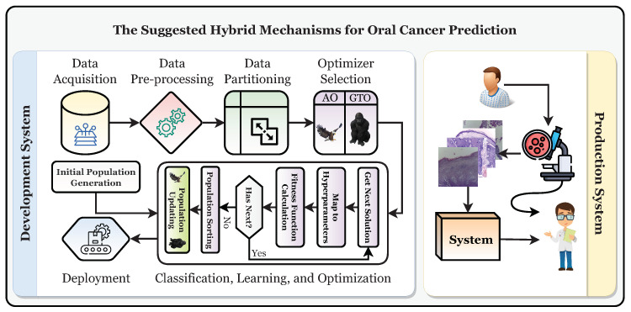**[1]**

**Chapter 3**

**System Analysis**

**System Analysis**

**1.1 Oral Cancer Detection AI Model Analysis Diagram**

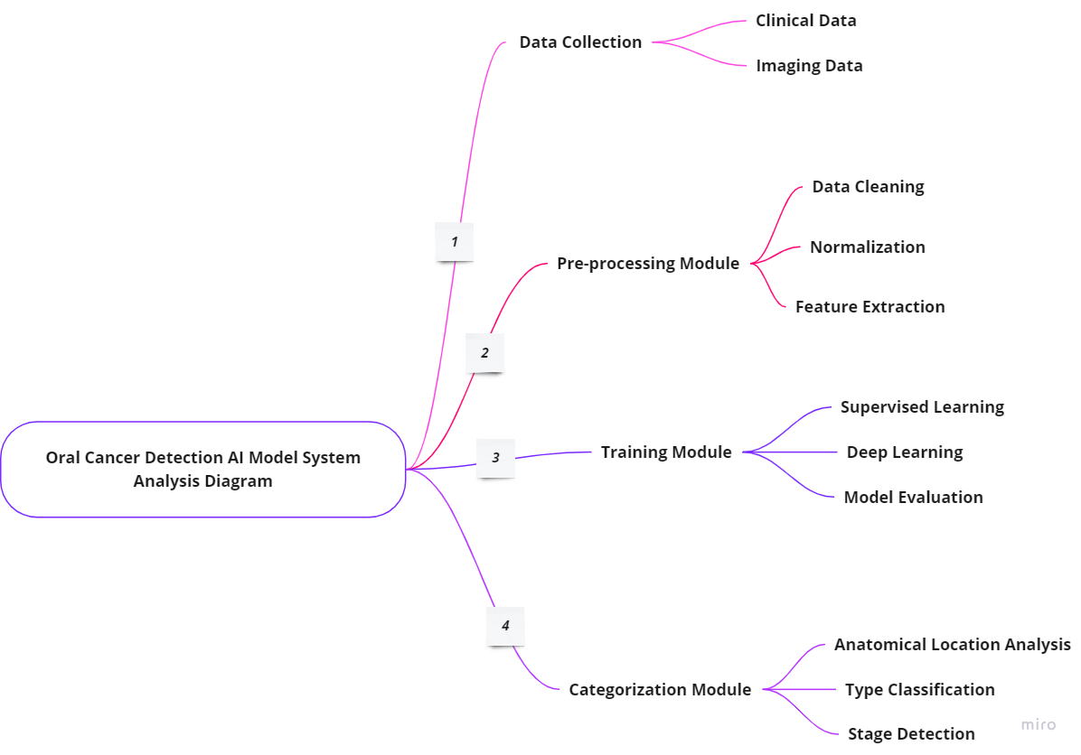

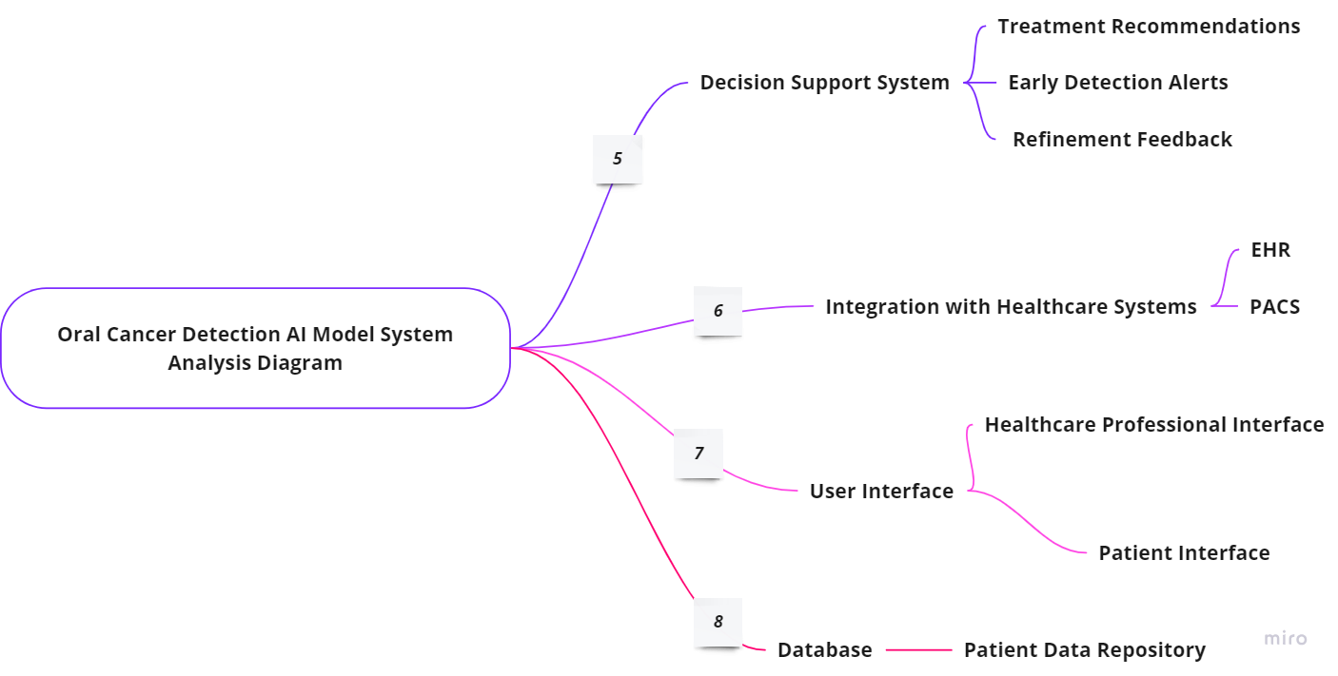

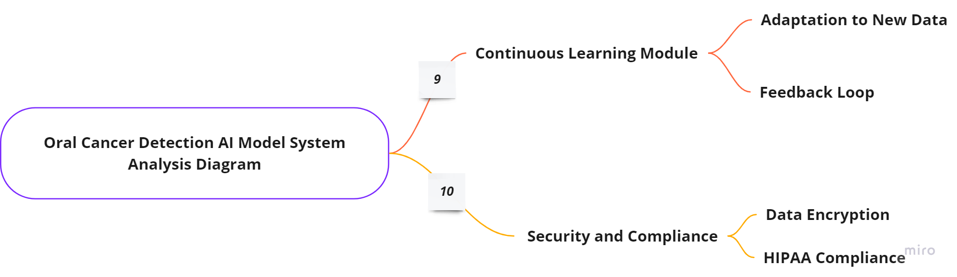

* Data Collection
  + Clinical Data: Patient records, medical histories, and diagnostic reports.
  + Imaging Data: X-rays, MRIs, CT scans, and mobile phone images.
* Pre-processing Module
  + Data Cleaning: Removal of noise and irrelevant information.
  + Normalization: Standardization of data for consistency.
  + Feature Extraction: Identification of relevant features for analysis.
* Training Module
  + Supervised Learning: Training the AI model using labeled data.
  + Deep Learning Algorithms: Implementation of neural networks for pattern recognition.
  + Model Evaluation: Assessing the model's accuracy and performance.
* Categorization Module
  + Anatomical Location Analysis: Identification of the specific location of oral cancer.
  + Type Classification: Categorization into squamous cell carcinoma, adenocarcinoma, etc.
  + Stage Detection: Determination of the cancer's stage based on imaging and clinical data.
* Decision Support System
  + Treatment Recommendations: Providing personalized treatment suggestions based on categorized data.
  + Early Detection Alerts: Notifying healthcare professionals of potential early-stage oral cancer cases.
  + Refinement Feedback: Incorporating continuous learning and model improvement feedback.
* Integration with Healthcare Systems
  + Electronic Health Record (EHR) Integration: Seamless interaction with patient data.
  + Picture Archiving and Communication System (PACS): Managing and interpreting medical imaging.
* User Interface
  + Healthcare Professional Interface: Visualization of categorized data, treatment recommendations, and alerts.
  + Patient Interface: Access to simplified information, test results, and potential risk alerts.
* Database
  + Patient Data Repository: Secure storage of patient records, ensuring privacy and compliance.
* Continuous Learning Module
  + Feedback Loop: Gathering insights from healthcare professionals to refine the model.
  + Adaptation to New Data: Ongoing adjustments to improve accuracy and relevance.
* Security and Compliance
  + Data Encryption: Ensuring the privacy and security of patient information
  + HIPAA Compliance: Adhering to healthcare data protection standards.

This system analysis diagram provides an overview of the oral cancer detection AI model, showcasing its various components, data flows, and interactions within the broader healthcare ecosystem.

**1.2 Oral Cancer Detection AI Model System Analysis**

In Systems Engineering, the System Development Life Cycle (SDLC) is a comprehensive process that encompasses planning, creation, testing, and deployment of an information system. Typically, this cycle consists of six stages: requirement analysis, design, development and testing, implementation, documentation, and evaluation. This chapter places a specific focus on the Analysis stage within our system, emphasizing its pivotal role in understanding and defining the requirements essential for the subsequent stages of the SDLC.

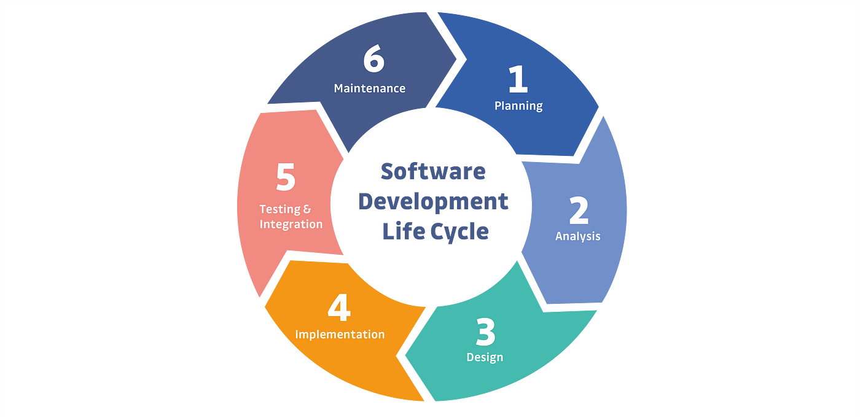

System analysis serves as an essential stage aimed at designing a system in a manner that ensures the compatibility and cohesion of its subsystems. This process provides a comprehensive understanding of the intricate structure of the system, enabling an advantageous assessment and comparison of subsystem functions with the complete system.

This chapter intricately elucidates the system analysis process, delving into

* Requirements
  + Functional Requirements
  + Nonfunctional Requirements
  + Domain Requirements
* Requirements Specifications
  + System Requirements
  + User Requirements
* System Architecture
  + User (Patient/Doctor) Interface
  + Server Interface
  + Administrator Interface
* Requirements Elicitation Techniques
  + Getting Data from the Internet
  + Getting Data from a Specific Organization
* Business Model

This systematic breakdown guides us through the critical components of the system analysis phase, offering insights into the various facets essential for the development of an effective oral cancer detection system.

**Requirements**

Requirements are essential specifications that a hardware or software system must fulfill to mitigate installation issues and ensure optimal performance. In this section, we elaborate on the specific requirements pertinent to the oral cancer detection system. The discussion is categorized into three subsections: Functional Requirements, Nonfunctional Requirements, and Domain Requirements. Each subset addresses distinct aspects critical to the successful development and operation of the system, aligning with best practices for creating an effective oral cancer detection solution.

**Nonfunctional Requirements**

Nonfunctional requirements for an oral cancer detection system, which is a critical phase in the software development life cycle, encompass various aspects related to the system's performance, usability, security, and scalability. Here is a list of nonfunctional requirements tailored for the oral cancer detection system

|  |  |
| --- | --- |
| Nonfunctional Requirements | Description |
| Performance | * **The system should provide real-time processing for efficient and prompt analysis of medical imaging data.** * **Response time for detecting potential cancerous abnormalities should not exceed [specify milliseconds] to ensure timely results.** |
| Scalability | * **The system should be scalable to accommodate an increasing number of users and data without compromising performance.** * **It should handle a growing database of patient records and medical images efficiently.** |
| Reliability | * **The system should demonstrate a high level of reliability, with minimal downtime and disruptions in service.** * **It should have built-in mechanisms for fault tolerance and recovery.** |
| Usability | * **The user interface should be intuitive and user-friendly, allowing healthcare professionals to navigate and interpret results easily.** * **The system should provide clear and concise notifications to users about the status of the analysis.** |
| Security | * **Patient data and medical images must be securely stored and transmitted to comply with privacy regulations.** * **Access to the system should be restricted, with role-based authentication for healthcare professionals.** |
| Interoperability | * **The system should integrate seamlessly with existing healthcare information systems and databases.** * **It should support standard medical data formats to facilitate interoperability with other medical devices.** |
| Compliance | * **The system should adhere to relevant healthcare industry standards, such as HIPAA, to ensure the security and confidentiality of patient information.** * **It should comply with any local or international regulations governing medical software applications.** |
| Maintainability | * **The system should be designed with modular and maintainable code for ease of updates and future enhancements.** * **It should provide tools for system administrators to perform routine maintenance tasks.** |
| Resource Utilization | * **The system should optimize the utilization of computing resources to ensure efficient performance without unnecessary resource strain.** * **It should be designed to operate on standard hardware configurations commonly found in healthcare environments.** |
| Documentation | * **Comprehensive documentation should be provided for system installation, configuration, and usage.** * **Technical documentation must be available for developers, facilitating ongoing maintenance and support.** |

These nonfunctional requirements are crucial for ensuring the success, reliability, and effectiveness of the oral cancer detection system throughout its lifecycle.

**Functional Requirements**

Functional requirements for an oral cancer detection system, a pivotal phase in the software development life cycle, outline the specific functionalities and capabilities that the system must possess to effectively detect and diagnose oral cancers. Here is a list of functional requirements tailored for the oral cancer detection system

|  |  |
| --- | --- |
| Functional Requirements | Description |
| Patient Data Input | * **The system should allow healthcare professionals to input and update patient information, including medical history, demographics, and risk factors.** |
| Medical Imaging Upload | * **Users should be able to upload various types of medical imaging data, such as X-rays, MRIs, and CT scans, for analysis.** |
| Preprocessing of Imaging Data | * **The system should preprocess medical images to enhance clarity and remove noise, ensuring accurate analysis.** |
| Automated Image Analysis | * **Implement machine learning algorithms to automatically analyze medical images, identifying potential indicators of oral cancer.** |
| Cancer Detection | * **The system should accurately detect the presence of oral cancer, indicating the location and extent of abnormalities within medical images.** |
| Stage Identification: | * **Provide functionality to determine the stage of oral cancer based on the analysis of medical imaging data, assisting in treatment planning.** |
| User Roles and Permissions: | * **Implement role-based access control to differentiate user roles (e.g., doctors, administrators) with varying levels of access and permissions.** |
| Notification System | * **Establish a notification system to alert healthcare professionals of completed analyses, prioritizing urgent cases.** |
| Integration with Electronic Health Records (EHR) | * **Enable seamless integration with existing EHR systems to retrieve and update patient records.** |
| Report Generation | * **Automatically generate detailed reports summarizing the analysis results, including identified abnormalities, recommended actions, and cancer stage.** |
| Decision Support System | * **Provide decision support tools, offering recommendations for further diagnostic procedures or treatment options based on analysis outcomes.** |
| Data Export Functionality | * **Allow users to export analysis results and reports in standard formats for sharing with other healthcare professionals or for archival purposes.** |
| User Interface | * **Design an intuitive and user-friendly interface, facilitating ease of navigation and interpretation of analysis results.** |
| Training and Support | * **Include features for user training and provide comprehensive documentation to ensure healthcare professionals can effectively utilize the system.** |
| Audit Trail | * **Implement an audit trail to log user activities, ensuring traceability and accountability for system interactions.** |
| Continuous Learning Mechanism | * **Incorporate mechanisms for continuous learning, allowing the system to improve its detection accuracy over time with additional data.** |

These functional requirements are essential for the successful development and deployment of an oral cancer detection system, enabling healthcare professionals to make informed decisions and improve patient outcomes.

**Domain Requirements**

Domain requirements for an oral cancer detection system within the software development life cycle encompass specific considerations related to the healthcare and medical imaging domain. These requirements ensure that the system aligns with the unique characteristics and needs of the oral cancer detection field. Here is a list of domain requirements for the oral cancer detection system

|  |  |
| --- | --- |
| Domain Requirements | Description |
| Medical Imaging Standards | * **The system must adhere to established medical imaging standards, such as DICOM (Digital Imaging and Communications in Medicine), for compatibility with various imaging devices.** |
| Healthcare Compliance | * **Ensure compliance with healthcare regulations, including HIPAA (Health Insurance Portability and Accountability Act), to safeguard patient privacy and data security.** |
| Clinical Accuracy | * **The system must demonstrate a high level of clinical accuracy in detecting and diagnosing oral cancer based on medical imaging data.** |
| Integration with Health Information Systems | * **Support seamless integration with existing health information systems, Electronic Health Records (EHR), and Picture Archiving and Communication Systems (PACS).** |
| Clinical Workflow Alignment | * **Align with the typical clinical workflow of healthcare professionals involved in oral cancer detection, ensuring a smooth integration into existing practices.** |
| User Training and Familiarity | * **Consider user training requirements to ensure that healthcare professionals can easily adapt to and effectively use the system within their daily routines.** |
| Patient Data Confidentiality | * **Prioritize the confidentiality and security of patient data, implementing measures to prevent unauthorized access and protect sensitive information.** |
| Device Compatibility | * **Ensure compatibility with a range of medical imaging devices commonly used in oral cancer diagnostics, allowing for flexibility in data input.** |
| Data Interoperability | * **Facilitate interoperability by supporting standard data exchange formats, enabling collaboration with other medical systems and devices.** |
| Data Quality and Integrity | * **Implement measures to maintain the quality and integrity of medical imaging data throughout the analysis process, minimizing errors and artifacts.** |
| Ethical Considerations | * **Adhere to ethical guidelines governing medical research and diagnostics, considering the implications of the system on patient well-being.** |
| Accessibility | * **Design the system to be accessible to healthcare professionals with varying technical expertise, ensuring widespread usability within the medical community.** |
| Regulatory Compliance | * **Comply with regulatory requirements specific to medical software applications, obtaining necessary approvals and certifications for clinical use.** |
| Continuous Monitoring and Improvement | * **Establish mechanisms for continuous monitoring of system performance and regular updates to enhance accuracy and reliability.** |

These domain requirements are crucial for the successful development and deployment of an oral cancer detection system, ensuring that it meets the unique needs and standards of the healthcare and medical imaging domain.

**Requirements Specifications**

Requirements specifications for an oral cancer detection system, as a critical phase in the software development life cycle, detail the specific features and functionalities essential for the successful development and deployment of the system. Here is a breakdown of requirements specifications tailored for the oral cancer detection system

* **System Requirements**
  + **Hardware Requirements**
  + **Software Requirements**
  + **Database Requirements**
* **User Requirements**
  + **User Authentication and Authorization**
  + **User Interface**
  + **Training and Support**
  + **Patient Data Management**
  + **Medical Image Analysis**
  + **Results Presentation**
  + **Communication and Notification**
  + **Integration with Existing Systems**

Certainly! Here's a detailed breakdown of the system and User requirements for an oral cancer detection system

**System Requirements 🡺 Hardware Requirements**

**System Requirements 🡺 Software Requirements**

**System Requirements 🡺 Database Requirements**

**User Requirements 🡺** **User Authentication and Authorization**

**User Requirements 🡺** **User Interface**

**User Requirements 🡺** **Training and Support**

**User Requirements 🡺** **Patient Data Management**

**User Requirements 🡺** **Medical Image Analysis**

**User Requirements 🡺** **Medical Image AnalysisUser Requirements 🡺** **Results Presentation**

**User Requirements 🡺** **Communication and Notification**

**User Requirements 🡺** **Integration with Existing Systems**

**System Architecture**

The system architecture for oral cancer detection represents the structural framework that defines the relationships, interactions, and components essential for the effective functioning of the entire system. In the context of oral cancer detection, the architecture revolves around three pivotal interfaces: the User (Patient/Doctor) Interface, the Server Interface, and the Administrator Interface.

* **User (Patient/Doctor) Interface**
* **Server Interface**
* **Administrator Interface**

Certainly! Here's a detailed breakdown of the System Architecturefor an oral cancer detection system

**System Architecture 🡺** **User (Patient/Doctor) Interface**

**System Architecture 🡺** **Server Interface**

**System Architecture 🡺** **Administrator Interface**

In conclusion, the intricacies of the system architecture for oral cancer detection lie in the seamless orchestration of these three interfaces. The careful consideration of design principles, functionalities, interactivity, data processing, security, integration, and administrative controls collectively forms a robust architecture, ensuring the effectiveness and reliability of the oral cancer detection system.

**Chapter 4**

**System Design**

**System Design**

**Software Modeling**

In software modeling, the system design for oral cancer detection with AI begins with conceptualizing the architecture and components required to achieve accurate and efficient detection. This involves defining the structure of the AI model, including the neural network architecture, data preprocessing techniques, and algorithmic approaches for image analysis.

The system design also encompasses the integration of various software tools and libraries essential for developing and deploying the AI model. This includes selecting appropriate programming languages, frameworks, and platforms that best suit the requirements of the oral cancer detection system.

Furthermore, the system design outlines the data flow and interactions between different modules within the system. This includes establishing communication protocols for data input, processing, and output, as well as defining the interfaces for user interaction.

Moreover, the system design addresses scalability and performance considerations to ensure the AI model can handle large volumes of data and provide timely results. This involves optimizing the computational resources, parallelizing tasks where applicable, and implementing caching mechanisms to enhance system responsiveness.

Overall, the system design phase in software modeling lays the foundation for developing an effective and reliable oral cancer detection system with AI, encompassing architectural decisions, software tools, data flow, and performance considerations.

**Concept Map**

A concept map is a visual representation that organizes and illustrates the relationships between various concepts or ideas. It consists of nodes, which represent individual concepts, and connecting lines or arrows that depict the relationships or connections between these concepts. Concept maps are used to clarify complex information, facilitate learning, and communicate ideas effectively.

In the context of oral cancer detection with AI, a concept map can illustrate the interconnected components involved in the detection process. These components may include the AI model itself, data sources such as medical images or patient records, preprocessing techniques for data preparation, feature extraction methods, classification algorithms, and output analysis.

The concept map can also depict the relationships between these components, such as the flow of data from input to output, the dependencies between different preprocessing steps, the influence of feature selection on classification accuracy, and the impact of classification results on treatment decisions.

Overall, a concept map serves as a valuable tool for conceptualizing and visualizing the complex relationships and processes involved in oral cancer detection with AI, helping researchers, practitioners, and stakeholders gain a better understanding of the underlying mechanisms and potential applications of AI in healthcare.

**Here's a concept map illustrating the relationships between the components of an intelligent approach for oral cancer diagnosis**

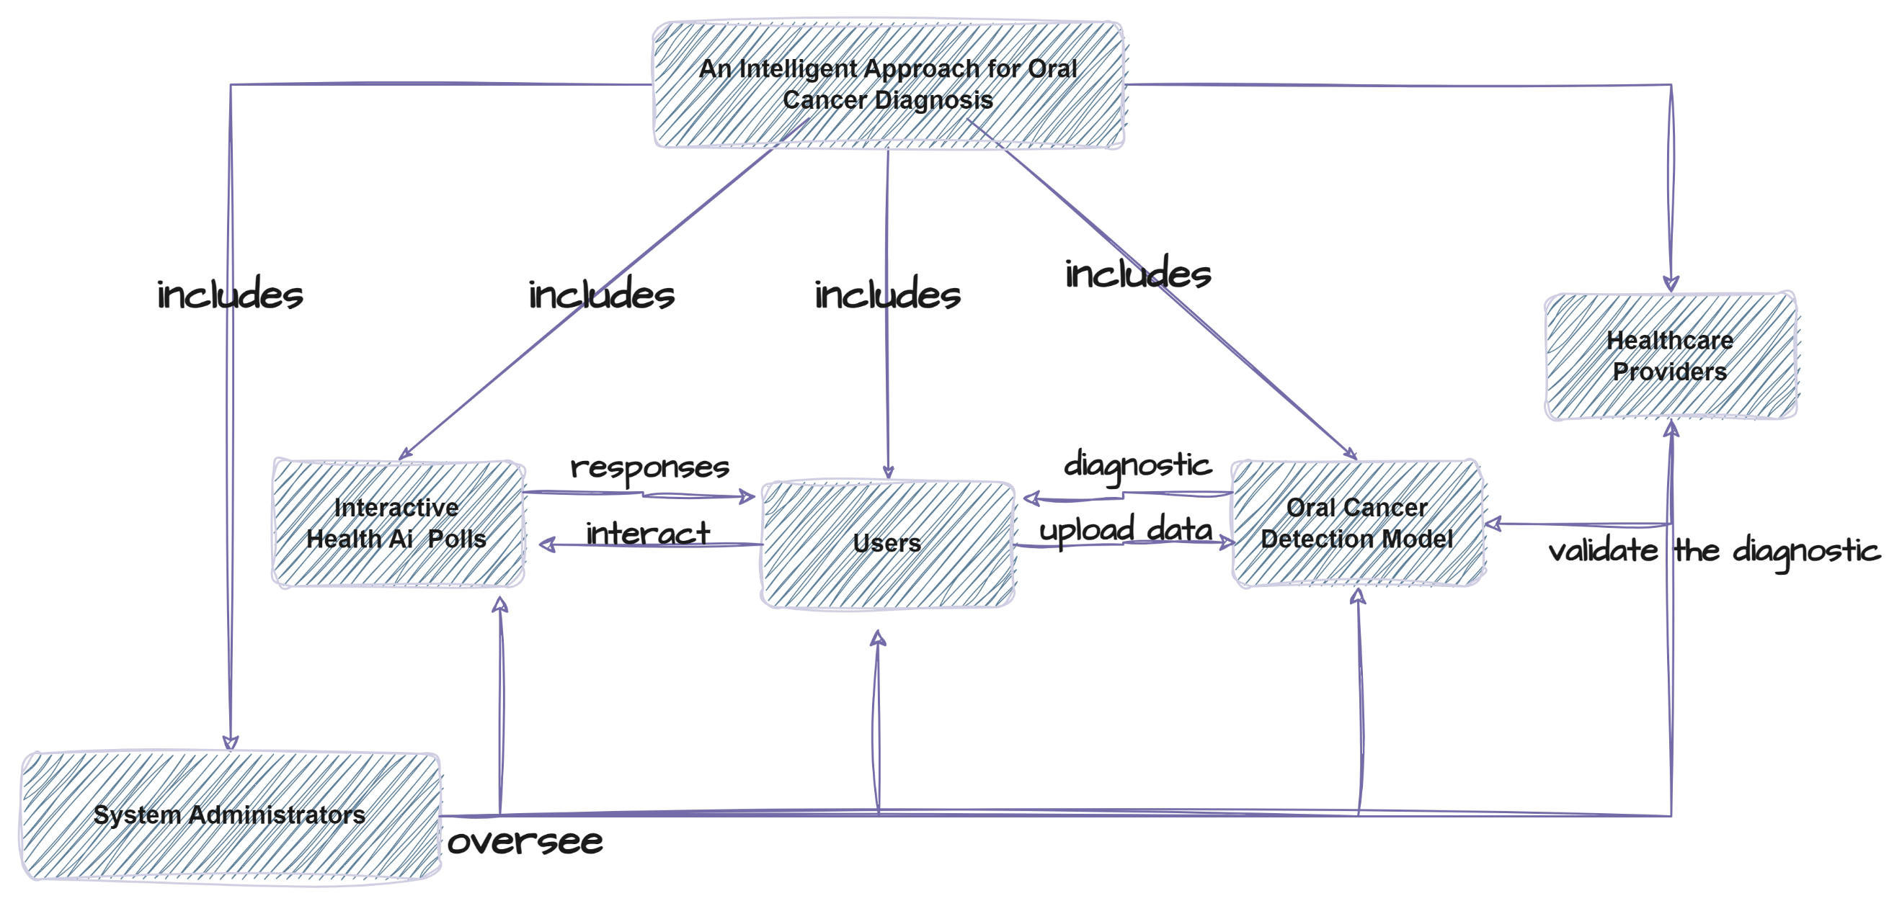

**Class Diagram**

A class diagram is a visual representation of the structure and relationships between classes or objects in a system. Classes represent entities or concepts within the system, while relationships depict how these classes interact or collaborate with each other. In the context of oral cancer detection with AI, a class diagram can illustrate the key components and their associations involved in the detection process.

At the core of the class diagram is the Oral Cancer Detection Model class, which encapsulates the functionality of the AI model responsible for analyzing medical images to detect signs of oral cancer. This class interacts with other classes representing various components such as data preprocessing, feature extraction, classification algorithms, and output analysis.

The Data Preprocessing class handles tasks related to preparing and cleaning the input data, ensuring that it is in a suitable format for analysis by the AI model. The Feature Extraction class extracts relevant features or characteristics from the preprocessed data, which are then used as input for the classification process.

The Classification Algorithm class implements the algorithm used by the AI model to classify medical images into different categories, such as cancerous or non-cancerous. It utilizes the extracted features to make predictions and generate diagnostic insights.

The Output Analysis class interprets the classification results produced by the AI model, providing additional analysis or contextual information to aid in decision-making by healthcare professionals. This class may also handle tasks such as generating reports or visualizations of the detection outcomes.

Additionally, the class diagram may include classes representing external components or interfaces, such as data sources (e.g., medical image databases), user interfaces for interacting with the system, and integration with healthcare provider systems for seamless communication and data exchange.

Overall, the class diagram serves as a blueprint for understanding the structure of the oral cancer detection system with AI, highlighting the interactions between different components and guiding the implementation of the software solution. It provides a visual representation of the system's architecture and facilitates communication among stakeholders involved in the development and deployment process.

**Here's a class diagram for an Intelligent Approach for Oral Cancer Diagnosis**

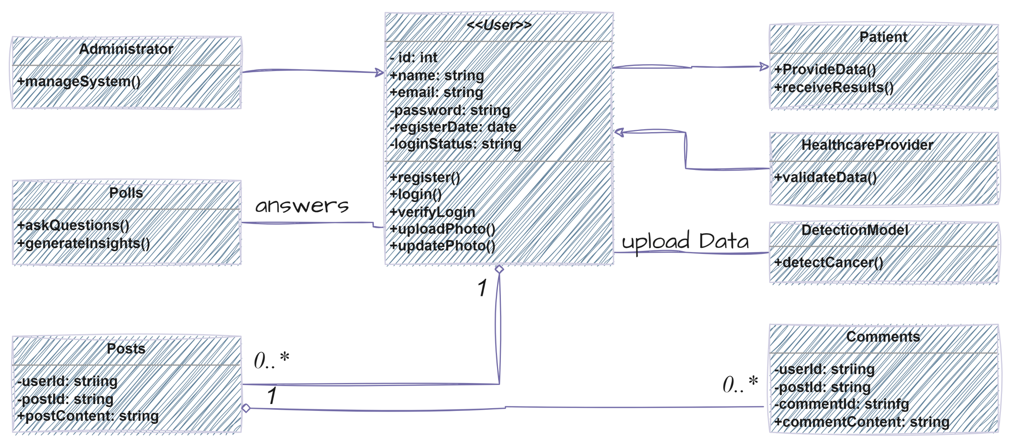

**Use Case Diagram**

A use case diagram is a visual representation of the interactions between actors (users or external systems) and the system under consideration to achieve specific goals or functionalities. In the context of oral cancer detection with AI, a use case diagram can illustrate the various scenarios or actions performed by different actors interacting with the system.

The primary actor in the use case diagram for oral cancer detection with AI is typically the healthcare provider or medical professional who interacts with the system to perform tasks related to diagnosis and treatment planning. Other actors may include patients, administrators, and external systems such as medical image databases or laboratory systems.

The use case diagram outlines the different use cases or functionalities supported by the system, each represented as an oval-shaped symbol, along with the actors involved in each use case. For example, common use cases in oral cancer detection may include "Upload Medical Images," "Run AI Analysis," "View Diagnosis Results," and "Generate Treatment Recommendations."

Overall, the use case diagram provides a high-level overview of the functionalities supported by the oral cancer detection system with AI and the actors involved in interacting with the system. It helps to identify the various user roles and their interactions with the system, guiding the design and development process to ensure that the system meets the needs of its users effectively.

**Here's a use case diagram for an Intelligent Approach for Oral Cancer Diagnosis**

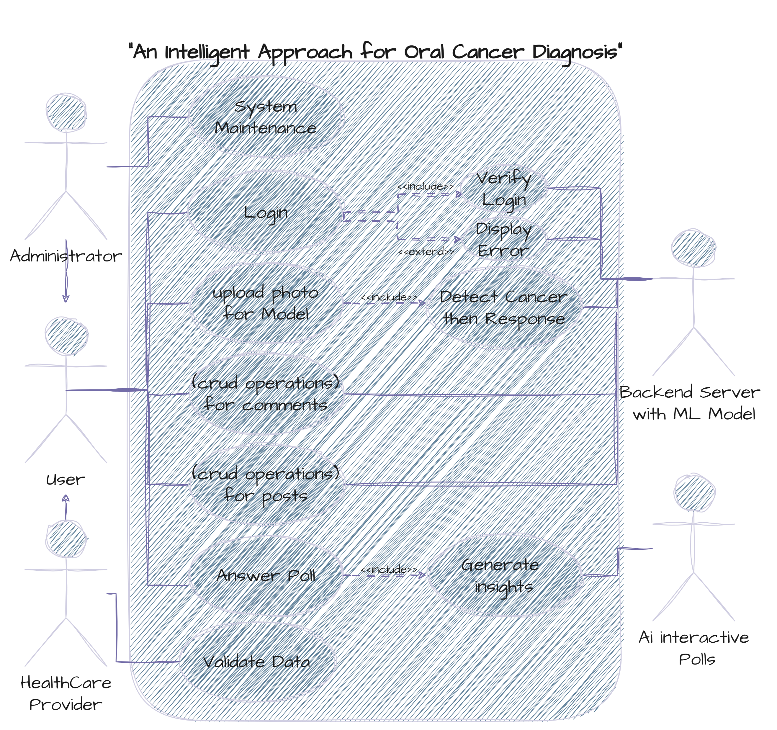

**Sequence Diagram**

A sequence diagram is a type of interaction diagram that depicts the sequence of interactions between objects or components in a system over time. In the context of oral cancer detection with AI, a sequence diagram illustrates the flow of messages or actions between various components involved in the detection process.

At the heart of the sequence diagram is the oral cancer detection system with AI, represented as the central component responsible for coordinating the detection process. Other components involved in the sequence diagram may include the user interface, image processing module, AI algorithm, database, and external systems.

The sequence diagram begins with the user interacting with the system through the user interface, initiating the process by uploading medical images for analysis. The user interface component sends a message to the image processing module, instructing it to preprocess the uploaded images and prepare them for analysis.

Next, the preprocessed images are forwarded to the AI algorithm component, which performs the analysis to detect any signs of oral cancer. The AI algorithm processes the images and generates a diagnosis report indicating the presence or absence of oral cancer, along with any additional information or recommendations.

Upon receiving the diagnosis report from the AI algorithm, the system updates the database with the analysis results for future reference. Additionally, the user interface component displays the diagnosis report to the user, providing them with the necessary information for further action or consultation with healthcare professionals.

**Here's a Sequence diagram for an Intelligent Approach for Oral Cancer Diagnosis**

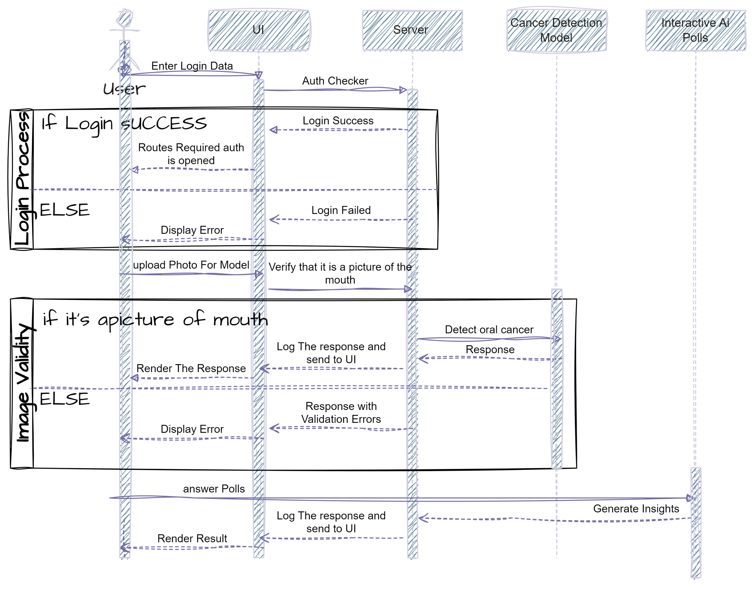

**Activity Diagram**

An activity diagram is a type of behavioral diagram in the Unified Modeling Language (UML) that illustrates the flow of activities or actions within a system. In the context of oral cancer detection with AI, an activity diagram provides a visual representation of the various steps involved in the detection process, from image upload to diagnosis generation.

At the core of the activity diagram is the oral cancer detection system with AI, which orchestrates the sequence of activities to effectively detect oral cancer. The diagram depicts the flow of control between different components and subprocesses within the system.

The activity diagram begins with the initiation of the detection process, triggered by the user uploading medical images through the user interface. This action initiates the "Image Upload" activity, which is represented as the starting point of the diagram.

Upon image upload, the system proceeds to preprocess the images, a step depicted by the "Image Preprocessing" activity. This involves enhancing and preparing the images for analysis to ensure optimal results.

Following preprocessing, the system engages in the core detection activity, where the AI algorithm analyzes the images to detect signs of oral cancer. This activity, represented as "AI Analysis," involves complex computations and image processing techniques to identify potential cancerous lesions.

Upon completion of the AI analysis, the system generates a diagnosis report based on the results obtained. This activity, labeled "Diagnosis Generation," involves compiling the analysis findings into a comprehensive report that provides information on the presence or absence of oral cancer, along with any additional insights or recommendations.

Finally, the diagnosis report is presented to the user through the user interface, completing the detection process. This step, denoted as "Report Presentation," involves displaying the diagnosis report in a user-friendly format for the user's review and consideration.

Overall, the activity diagram provides a clear and structured visualization of the sequential activities involved in the oral cancer detection process with AI. It serves as a valuable tool for understanding the flow of control within the system and optimizing the detection workflow for efficiency and accuracy.

**Here's an Activity diagram for an Intelligent Approach for Oral Cancer Diagnosis**

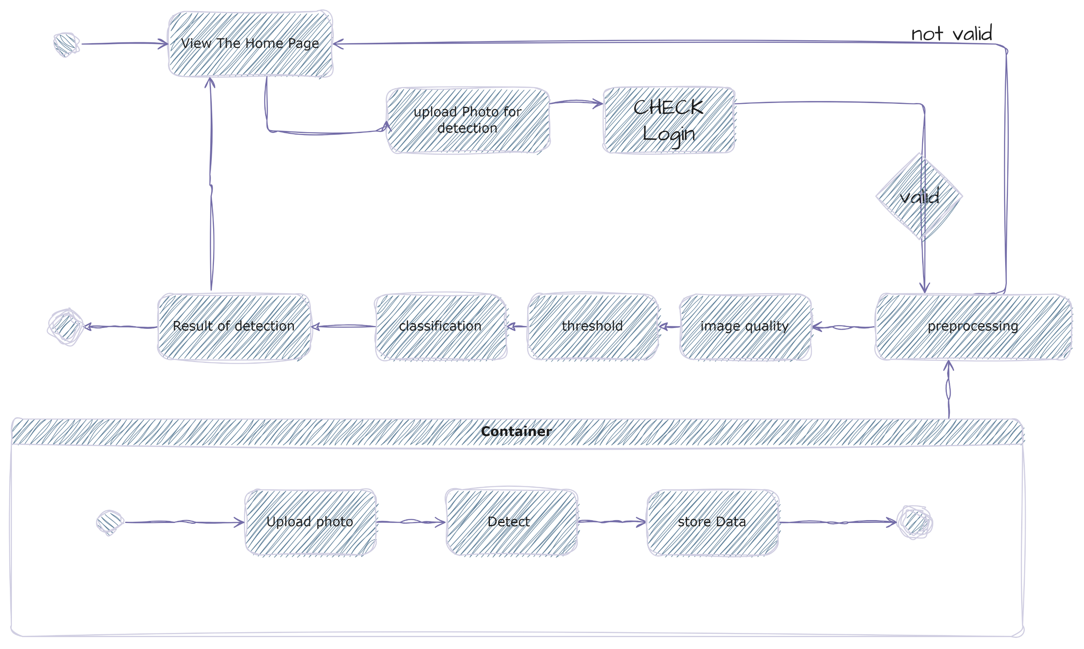

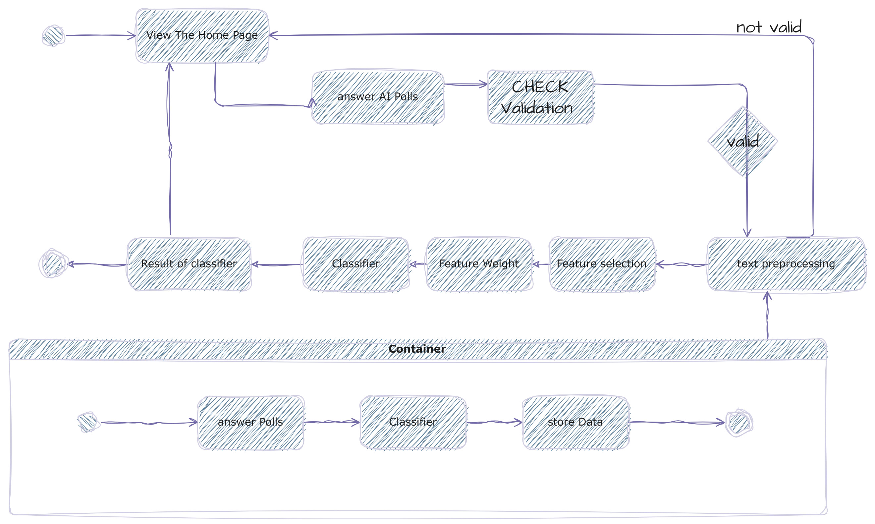**Here's an Activity diagram for an Ai Polls for Oral Diagnosis**

**Business Model**

A business model for oral cancer detection with AI leverages advanced technology to provide accurate diagnostic solutions while ensuring sustainable growth. It encompasses revenue generation strategies, target market identification, and value proposition development. The model focuses on enhancing diagnostic accuracy, improving patient outcomes, and streamlining healthcare workflows through cutting-edge AI algorithms.

The target market includes healthcare providers, clinics, hospitals, and research institutions. The value proposition lies in the AI-powered system's ability to detect oral cancer at early stages, enabling timely intervention and treatment. Revenue generation strategies may involve subscription-based models, pay-per-use fees, or licensing agreements with healthcare facilities. Partnerships with medical device manufacturers, imaging centers, and telehealth platforms expand the solution's reach.

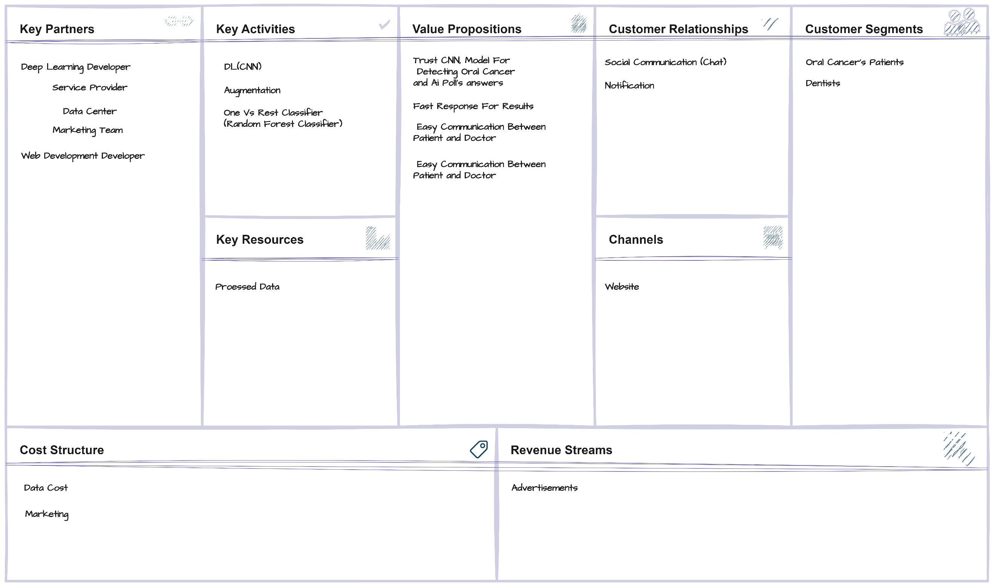

**Graphical User Interface - GUI**

Login Page



Register Page



Home Page

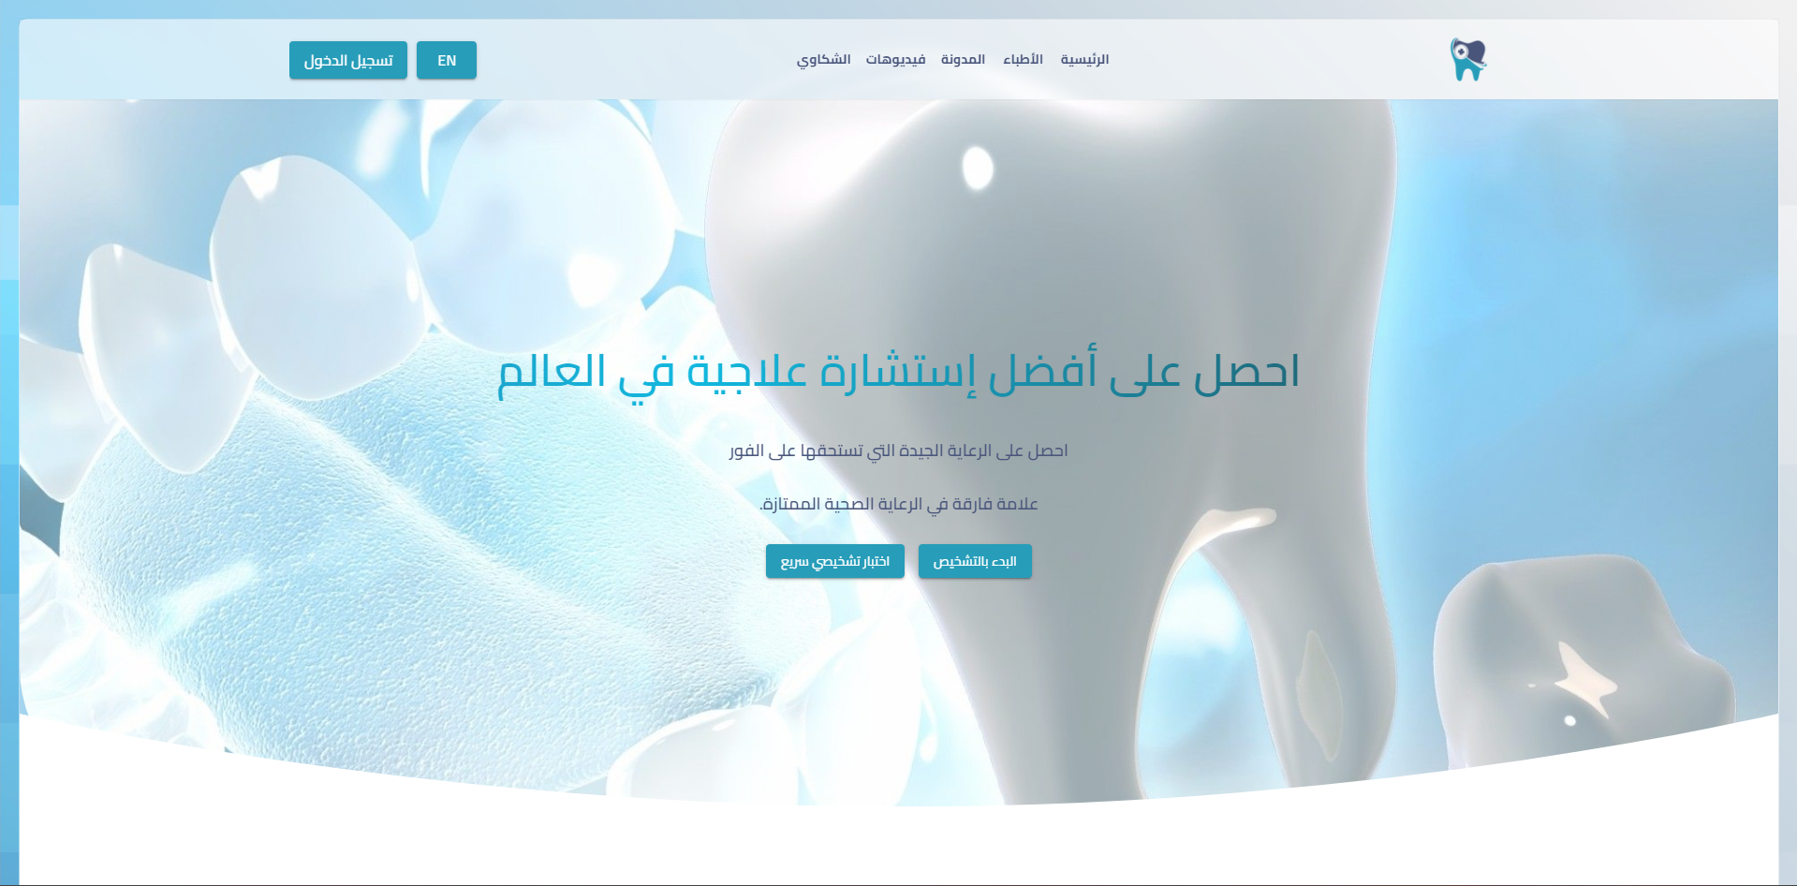

Doctors Page

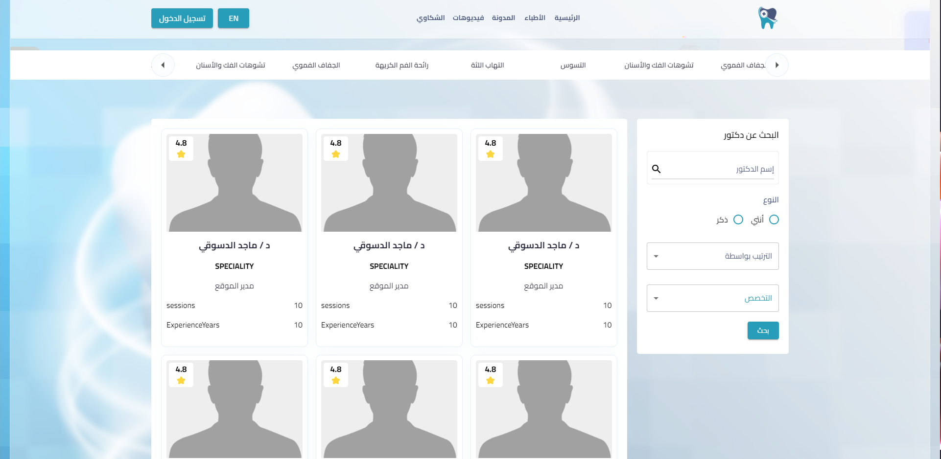

Blog Page

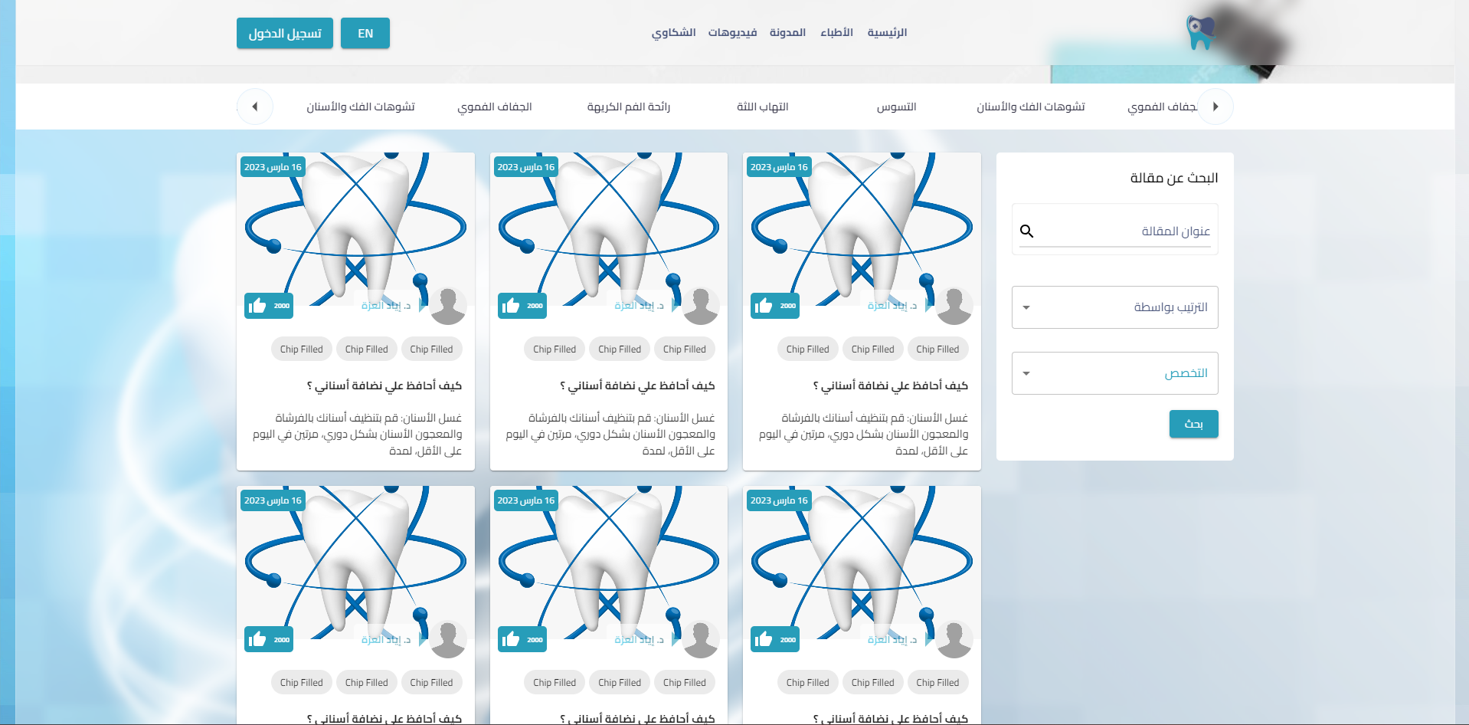

Videos page



1. https://www.ncbi.nlm.nih.gov/pmc/articles/PMC10604828/